CQRS

COMMAND QUERIES RESPONSIBILITY SEGREGATION
- Why we use CQRS and MediatR is to get rid the Services and IServices files that will make us get headache when to many functions in the future

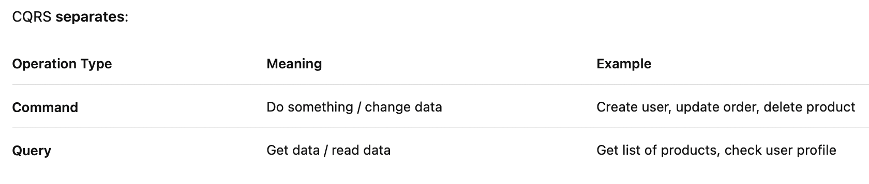

IMPLEMENTATION OF CQRS
- Installing MediaTR package
- Creating concrete class
- Registration and use of the MEDIATR
STEP OVERVIEW
- Install the latest version of MediatR in our Application Module
- Check again our RestaurantsService.cs
  - Create function will be represented as COMMAND because it’s going to put or insert a new resource to the database
  - GetAllRestaurants and GetById will be represented as 2 separate QUERIES because they are only returning the resources to the end client, and there is no logic to save the data.
- Create a new class in Restaurants.Application/Restaurants/Commands/CreateRestaurant/CreateRestaurantCommand.cs
  - Make sure public class
  - Get the same properties as CreateRestaurantDto.cs
  - Add MediatR package called IRequest
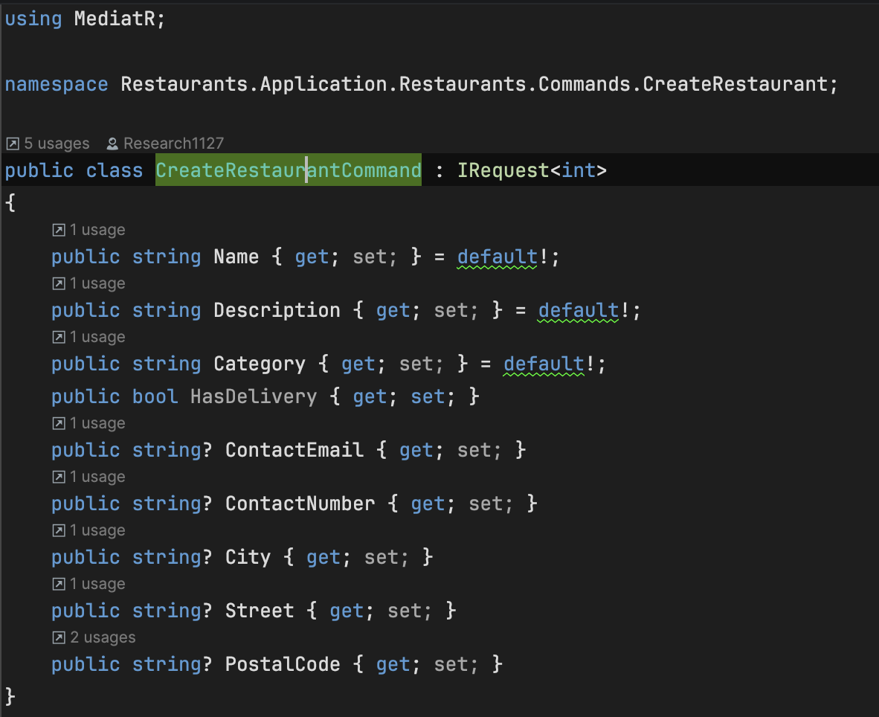

- Create a new class in the same folder called CreateRestaurantCommandHandler.cs
  - Make sure public class
  - Click at the class name and generate code for missing member
  - Copy from Create method from RestaurantService.cs and pastes it to the code that we generate earlier
  - Debug the code so no red line or error for the code by adding the dependency
  - The last part is dto part need to change as request
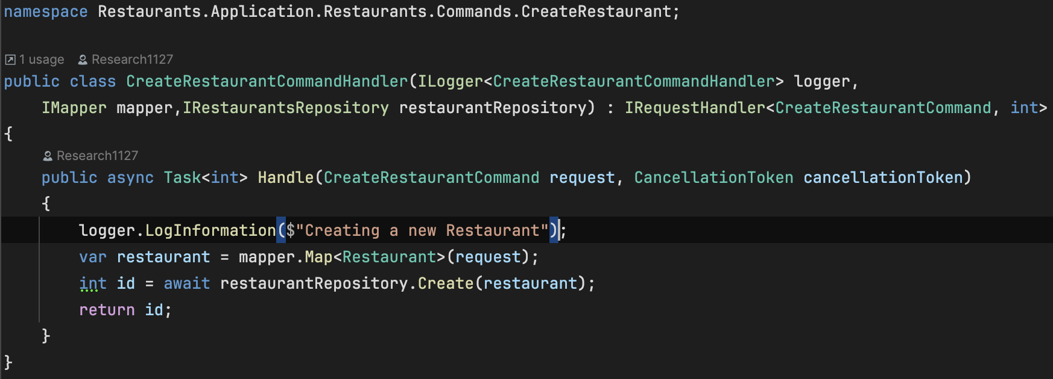
- Edit CreateMap method in RestaurantsProfile.cs
  - Change CreateMap<CreateRestaurantDto, Restaurant>() to CreateMap<CreateRestaurantCommand, Restaurant>()
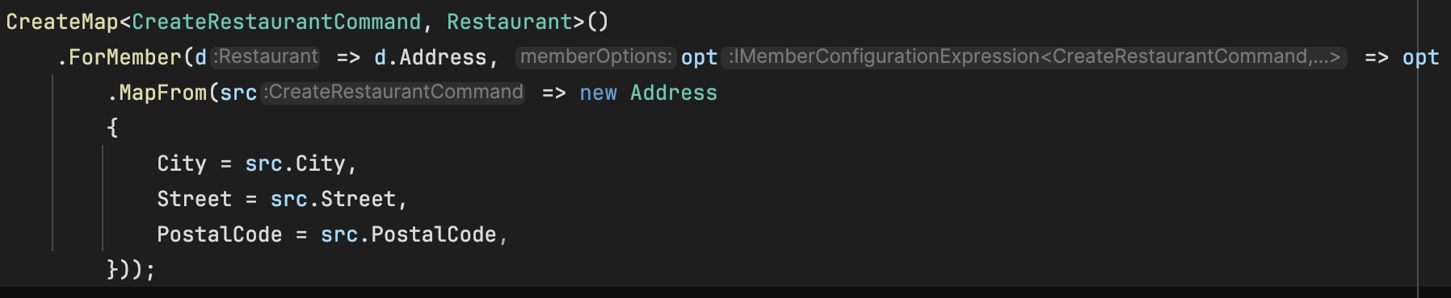
- Edit CreateRestaurantDtoValidator.cs
  - Move the file to the Restaurants.Application/Restaurants/Commands/CreateRestaurant
  - Rename it to the CreateRestaurantCommandValidator.cs
  - Adjust the constructor’s name also
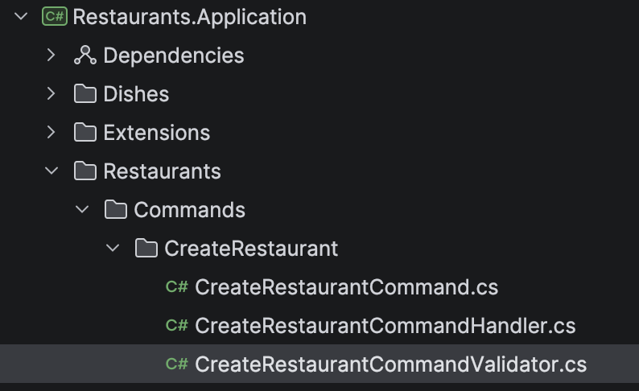

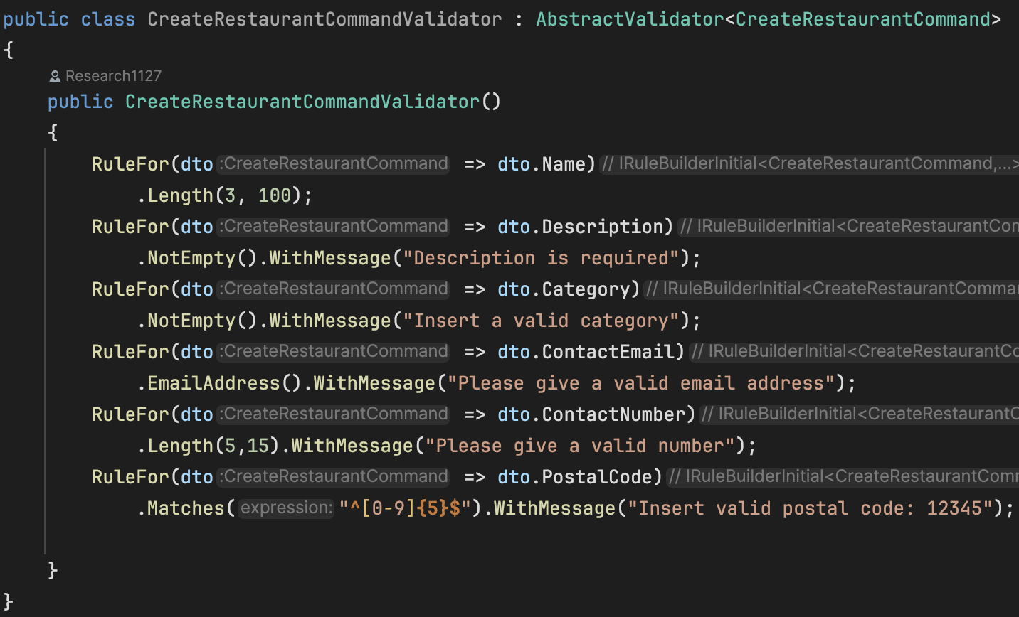
- Delete CreateRestaurantDto.cs permanently in our source code
- Delete the Create method that we copy before in RestaurantsService.cs

- In Application Module create this class /Restaurants/Queries/GetAllRestaurants/GetAllRestaurantsQuery.cs
  - Make sure public class
  - Add MediatR package called IRequest and use IEnumerable to return the collection of the Restaurant DTO object.
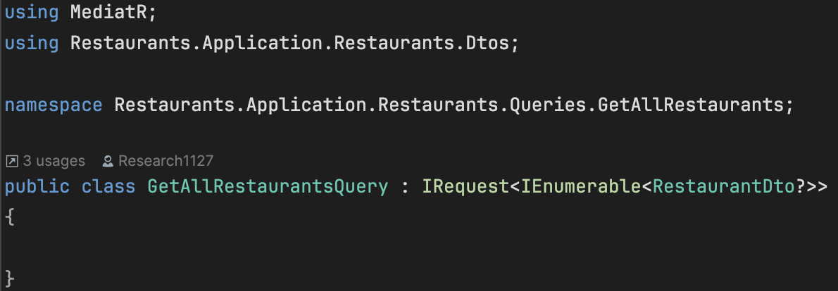
- In the same folder create GetAllRestaurantsQueryHandler.cs
  - Make sure public class
  - Add MediatT package called IRequestHandler and insert GetAllRestaurantsQuery and the second type we will have to specify the return value which is IEnumerable of restaurant Dto class
  - After that click on the class and generate code and add missing member
  - Go to RestaurantsService.cs and copy GetAllRestaurants method and pastes in the code we generate earlier
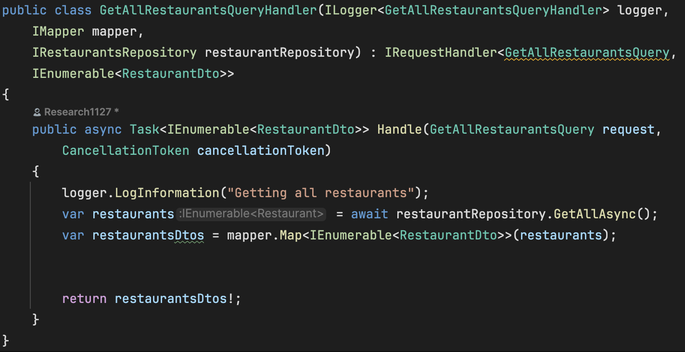
- Do the similar thing for GetRestaurantsByIdQuery
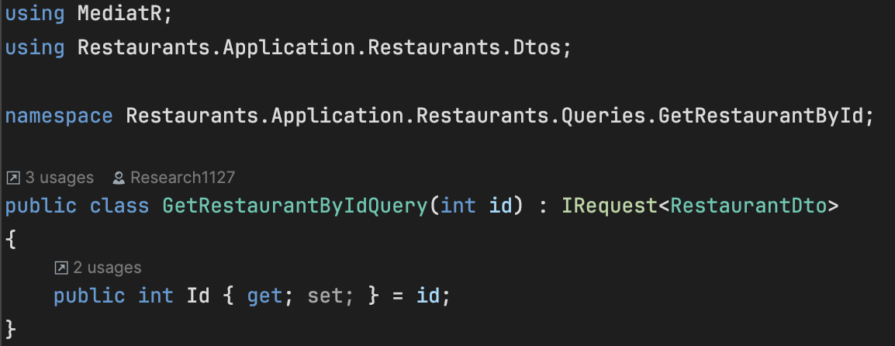

- Do similar thing to GetRestaurantsByIdQueryHandler
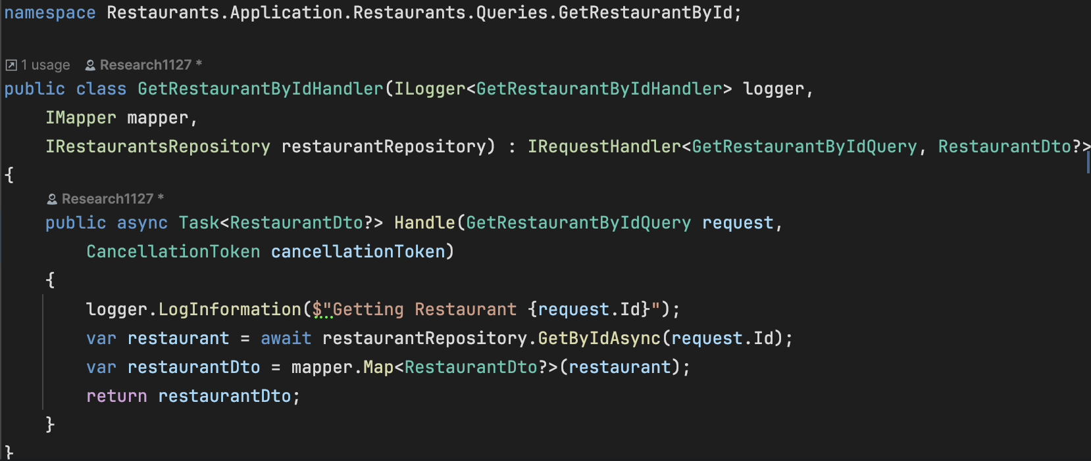
- Then we remove the RestaurantsService.cs and IRestaurantsService.cs files as we no longer need those files.
- Now we need to add the MediatR in our ServiceCollectionExtension.cs in our application module.
  - Delete the addscoped for RestaurantsService.cs and IRestaurantsService.cs
  - Add service for AddMediatR
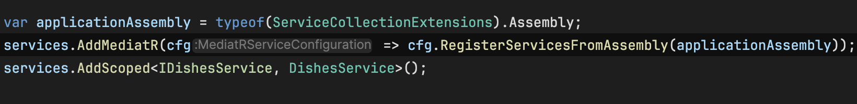
- Last, we need to change our RestaurantsController.cs
  - Replace RestaurantsService.cs and IRestaurantsService.cs part
  - Change to use IMediator
